**Template and Detailed Paper Guidelines**

**Abstract ID: 1234**

**Abstract**

For the abstract section heading, use 12-point, Times New Roman, bold, centered font, followed by a single blank line. Then include the abstract for your paper (max 250 words), using 10-point, Times New Roman, full-justified font. Include a single blank line after the abstract.

**Keywords** (not numbered, 12 point, Times New Roman, bold, left justified)

Industrial engineering, operations research, stochastic processes (Include three to five keywords related to the main topic. This section does not have a section number.)

## Page Layout

All papers are limited to **6 pages** (*including title and author data, references, and figures and tables*) and should follow the following format and layout:

* Page Size: 8.5" x 11" (Letter).
* Top and bottom margins: 1.00"
* Left and right margins: 1.00"
* First page header: Conference proceedings editors’ information (follow this template)
* Header (from pages two to six): No header for initial submission. The last names of the authors will be included in the header for accepted manuscripts during final submission.
* Spacing and Justification: Single line-spacing with full-justified text.
* Paragraphs: No indentation of paragraphs. Use a single blank line to separate paragraphs.
* No footers or page numbers.

## Paper/Case Study Title

The following information should be included at the top of the first page:

* Paper title: 16-point, Times New Roman, bold, centered, upper and lower case
* Abstract ID (initial submission): 12-point, Times New Roman, bold, and centered.
* Leave space on this page for author names and organizations to ensure the 6-page limit is not exceeded if the manuscript is accepted.

## Text Sections and Headings

## Text Sections and Headings

Text should be organized into sections and subsections. A single line should separate paragraphs; no paragraph indentations should be used.

Font guidelines are as follows:

* Section Headings: Numbered, 12-point, Times New Roman, bold, upper and lower case, left-justified. Leave one blank line above only.
* Section Sub-headings: Numbered, 10-point, Times New Roman, bold, upper and lower case, left-justified. Leave one blank line between subsections.
* Regular text: 10-point, Times New Roman, full-justified, with a single line between paragraphs.

## Bullets

Bullet guidelines are as follows:

* First level bullet
* Second level bullet
  + Third level bullet

## 4. Figures, Tables, and Captions

Tables and figures should be included in the main text (see Figure 1 and Table 1), as close to the point of their introduction as possible. Figure and table numbering should be independent. Captions guidelines are as follows:

* Table captions: 10-point, Times New Roman, centered (if a single line) or full-justified (if multiple lines). Place caption above the table; leave one blank line above and below the caption. For an example, see Table 1 below.
* Figure captions: 10-point, Times New Roman, centered (if a single line) or full-justified (if multiple lines). Place caption below the figure; leave one blank line above and below. As an example, see Figure 1 below.

Table 1: Example table listing preventive maintenance parameters for an electric distribution case study

|  |  |  |  |
| --- | --- | --- | --- |
| Critical component (*Xn*) | *αn* | *βn* |  |
| Transmission System 2 | 2.0 | 1.5 | 7.5 |
| Distribution Company 1 | 1.2 | 1.75 | 8.0 |
| Distribution Company 2 | 1.0 | 1.75 | 12.0 |
| Distribution Company 3 | 1.3 | 1.75 | 10.5 |

This is an example paragraph to demonstrate the guidelines for the table (above) and figure (below).

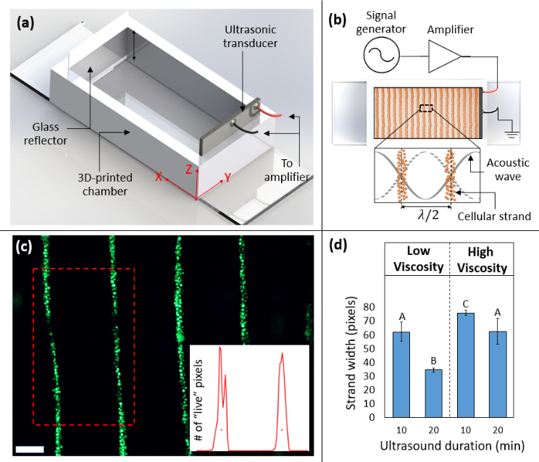

Figure 1: Example figure demonstrating **(a, b)** the concept of ultrasound-assisted 3D-biofabrication process, and **(c, d)** experimental results with aligned cells. A figure could include a single or multiple schematics, line and CAD drawings, photos, graphs etc. arranged in a concise layout. Labels within the figure should be legible. Paragraph text and captions should not be wrapped around the figure.

## 5. Equations

Equations should be centered and numbered in order of appearance. Place the equation number in parentheses, positioned flush to the right margin. Prepare equations with an Equation Writer; screenshots of equations should not be used. Leave one line before and after every equation. See Equation (1) below as an example.

$t_{align}=\frac{9ληρ_{a}}{2πkr^{2}Φ}lnln \left(\frac{tantan \left(kx_{0}\right) }{tantan \left(kx_{f}\right) }\right)$ (1)

## Acknowledgements

Acknowledgement of funding support and/or any other kind of assistance should be contained in an “Acknowledgements” section (this section should have no section number), located immediately before the “References and Citations” section.

## References and Citations

The IEEE style [1] should be followed for references and citations for each manuscript submitted to the IISE Annual Conference. In brief, references are numbered sequentially by order of occurrence (not alphabetically) in the text and listed in a separate section labeled References (no section number) at the end of the manuscript. Within the text, they should be cited by the corresponding list number in square brackets [1]. When referring to two references, use this format [2, 3]. If you refer to more than two documents listed consecutively, use this format [2-4]. The following provides example formats for different types of reference documents.

**References**

1. Institute of Electrical and Electronics Engineers, “IEEE Reference Guide,” IEEE Periodicals, V 11.12.2018, 2018. [Online]. Available: [https://ieee-dataport.org/IEEECitationGuidelines.pdf](https://ieee-dataport.org/sites/default/files/analysis/27/IEEE%20Citation%20Guidelines.pdf). [Accessed September 16, 2020].
2. N. Yodo, P. Wang, “Resilience Allocation for Early Stage Design of Complex Engineered Systems,” *Journal of Mechanical Design*, vol. 138, no. 9, pp. 091402 (10 pages), July 2016, doi: 10.1115/1.4033990.
3. Z. Tan, R. A. Shirwaiker, “A Review of the State of Art and Emerging Industrial and Systems Engineering Trends in Biomanufacturing,” in *Proceedings of 2012 Industrial and Systems Engineering Research Conference*, Orlando, FL, USA, May 19-23, 2012, pp. 2407-2414.
4. T. Chang, R. Wysk, H. Wang, *Computer-Aided Manufacturing*, *3rd* ed. Upper Saddle River, NJ, USA: Prentice Hall, 2006.